Bearing Fault Detection and Classification Using Machine Learning

Abstract
Bearings are crucial components in rotating machinery, and their failure can lead to significant operational disruptions. This paper explores machine learning-based approaches for the detection and classification of bearing faults using time-domain statistical features. We employ datasets from CWRU and Paderborn, and evaluate multiple machine learning algorithms, including SVM, KNN, Decision Trees, and 1D-CNN. The results indicate that the SVM classifier achieves the highest accuracy. Additionally, CNN models trained on raw signal segments without preprocessing demonstrate strong classification capabilities. The study concludes that combining traditional and deep learning approaches enhances fault detection accuracy and robustness.

1. Introduction
Bearings are essential components in rotating machinery, and their failure can lead to serious operational disruptions and high maintenance costs. Early detection of bearing faults is vital for ensuring equipment reliability and implementing effective predictive maintenance strategies. Traditional methods based on manual vibration signal analysis are limited in scalability and often require domain expertise. Machine Learning (ML) techniques provide a powerful alternative by automatically learning patterns from data to identify faults. This project explores various ML algorithms to classify bearing faults using statistical features derived from vibration signals. Two benchmark datasets—CWRU and Paderborn—are utilized to train and validate the models. The study compares the performance of Support Vector Machines (SVM), K-Nearest Neighbors (KNN), Decision Trees, and 1D Convolutional Neural Networks (CNN). The goal is to develop an accurate and generalizable fault detection system suitable for industrial applications.

2. Related Work
Bearing fault diagnosis is essential in predictive maintenance for detecting and classifying faults in rotating machinery using vibration signals. Traditional methods relied on handcrafted features, while modern ML and DL approaches automate feature learning for higher accuracy. Benchmark datasets like CWRU and Paderborn have advanced research, but challenges such as data imbalance, noise, domain adaptation, and hardware demands remain, driving the need for more robust real-world solutions.

2.1 Traditional Approaches
Early bearing fault diagnosis studies used handcrafted features like RMS, kurtosis, and skewness from vibration signals (Smith & Zhang, 2020). ML models such as SVM, Decision Trees, and KNN (via Scikit-learn) performed well on lab datasets but struggled in noisy industrial settings (Lei et al., 2016). The CWRU dataset enabled controlled evaluations but lacked real-world diversity, while Paderborn’s dataset offered more realistic conditions yet remained limited in scale. Though computationally efficient and interpretable, these methods relied heavily on expert-driven feature engineering, prompting a shift to automated feature extraction with deep learning.

2.2 Deep Learning-Based Methods
Deep learning transformed fault diagnosis by automating feature extraction from raw vibration signals. CNNs achieved high accuracy and noise resilience (Zhang et al., 2017; Wang et al., 2018), while 1D CNNs enabled real-time detection (Ince et al., 2016). DBNs provided hierarchical feature learning but were computationally intensive (Shao et al., 2017). LSTMs captured temporal dependencies but lacked interpretability and required careful tuning (Janssens et al., 2016). Surveys (Zhao et al., 2019; Lei et al., 2016) highlighted scalability challenges in industrial settings, stressing the need for hardware optimization and frameworks like Keras (Chollet, 2015). Despite these issues, DL remains central to predictive maintenance research.

2.3 Domain Adaptation and Few-Shot Learning
Researchers use transfer learning and domain adaptation to address dataset limitations and domain shifts. Pan and Yang (2010) reviewed cross-domain generalization methods, while Boudiaf et al. (2020) applied adversarial training to enhance robustness. Few-shot learning (Zhu et al., 2021) reduced reliance on large labeled datasets, though performance declined under extreme variability. These techniques, combined with specialized architectures, advance real-world deployment. However, optimization challenges, interpretability issues, and hardware demands hinder adoption. Ongoing research explores hybrid approaches blending domain expertise with deep learning for scalable, reliable fault diagnosis.

2.4. Research Gaps and Contributions
Despite significant progress in bearing fault diagnosis using machine learning and deep learning, key challenges remain. Many studies rely heavily on single datasets, such as CWRU or Paderborn, which limits model generalization to real-world industrial environments. Traditional approaches depend on manual feature engineering (e.g., RMS, kurtosis, skewness), often overlooking complex fault patterns, while classical ML models like SVM and KNN show performance drops in noisy or imbalanced data conditions. Deep learning models, though accurate, face scalability issues due to their demand for large labeled datasets and high computational resources. Furthermore, cross-domain adaptation remains underexplored, with limited solutions for handling variations in operating conditions without retraining.

3. Proposed Methodology
The proposed methodology develops a robust bearing fault diagnosis framework by combining machine learning and deep learning approaches using vibration signals from the CWRU and Paderborn datasets. Raw signals are preprocessed, labeled into four categories (normal, inner race, outer race, ball fault), and merged to improve data diversity and model generalization. For traditional ML models, statistical features such as RMS, kurtosis, skewness, and mean are extracted and normalized using Z-score standardization, with labels encoded numerically. Models including SVM with RBF kernel, KNN, and Decision Trees are trained on the engineered features to evaluate classification accuracy. In parallel, a 1D-CNN is implemented for end-to-end learning, extracting features directly from raw signals through convolutional and pooling layers, followed by dense layers for classification. Stratified k-fold cross-validation (k=5) ensures robust evaluation while preserving class distribution, and performance is assessed using accuracy, precision, recall, and F1-score. Visualization tools such as PCA projections, confusion matrices, and learning curves provide further insight into data separability and model effectiveness. This integrated approach demonstrates the strengths of interpretable ML models alongside scalable deep learning, offering a reliable, transferable framework for real-world bearing fault diagnosis and predictive maintenance.

3.1 Methodology:
The proposed methodology for real-time bearing fault diagnosis begins with data acquisition from the widely used CWRU bearing vibration dataset. The raw signals undergo preprocessing, including FIR filtering, segmentation, and label encoding, to remove noise and standardize inputs. In the feature extraction stage, statistical time-domain features (RMS, standard deviation) and frequency-domain features (energy) are computed and normalized. For classification, machine learning models such as SVM, KNN, and Decision Tree are trained using extracted features, while a 1D-CNN is employed directly on segmented raw signals. The trained models are subjected to evaluation metrics such as accuracy, F1-score, and confusion matrix to validate performance. Once optimized, the best-performing models are saved in .pkl or .h5 formats along with scalers and encoders for reuse. A Flask-based web application is developed to allow users to upload vibration data files for diagnosis. During real-time prediction, uploaded signals are preprocessed, features are extracted, and the trained models predict the fault type. Finally, the system is deployed on cloud platforms such as Render or Heroku to ensure accessibility and scalability. This pipeline ensures an end-to-end solution for accurate, real-time bearing fault diagnosis using both ML and DL techniques.
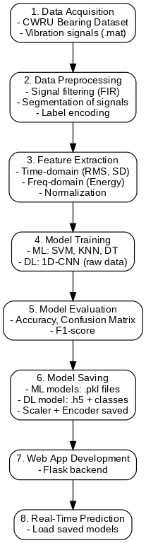
Figure 1: Methods to train the machine for fault identification and classification

3.2. Support Vector Machine (SVM) Algorithm

1: Encode class labels: fault ∈ {normal, inner, outer, ball} → 0,1,2,3

2: Normalize features using Z-score standardization:

X_scaled = (X - μ) / σ

3: Initialize StratifiedKFold cross-validation (n=5)

4: For each fold do:
5: Split into (X_train, y_train), (X_test, y_test)
6: Define SVM classifier: SVC(kernel='rbf', C=1, gamma='scale')
7: Train model on (X_train, y_train)
8: Predict: y_pred = model.predict(X_test)
9: Evaluate: Accuracy, Confusion Matrix, Precision, Recall, F1-score, ROC and AUC
(if probabilities computed)
10: end for
11: Report average metrics across all folds

3.2.1. RBF Kernel (Radial Basis Function) in SVM
In the Support Vector Machine (SVM) model used for this project, the Radial Basis Function (RBF) kernel played a central role in enabling non-linear classification of bearing fault data. The RBF kernel calculates the similarity between two data points using a Gaussian function and is defined by the formula:
K(x_i, x_j) = exp(-γ * ||x_i - x_j||²)
where gamma γ controls the influence of a single training example. A smaller gamma value means a wider influence, while a larger gamma focuses more narrowly on nearby points. The RBF kernel allowed the SVM to map the feature space into a higher-dimensional space where classes that were not linearly separable in the original space could now be effectively separated. This property made it particularly suitable for bearing fault classification, where class boundaries are often complex due to overlapping feature distributions in real-world signal data.

3.3. K- Nearest Neighbors Algorithm1: Encode class labels: fault ∈ {normal, inner, outer, ball} → 0,1,2,3
2: Normalize features using Z-score standardization:
X_scaled = (X - μ) / σ
3: Initialize StratifiedKFold cross-validation (n=5)
4: For each fold do:
5: Split into (X_train, y_train), (X_test, y_test)
6: Define KNN classifier: KNeighborsClassifier(n_neighbors=5)
7: Train model on (X_train, y_train)
8: Predict: y_pred = model.predict(X_test)
9: Evaluate: Accuracy, Confusion Matrix, Precision, Recall, F1-score
10: end for
11: Report average metrics across all folds

3.4. Decision Tree Algorithm
1: Encode class labels: fault ∈ {normal, inner, outer, ball} → 0,1,2,3
2: Normalize features using Z-score standardization:
X_scaled = (X - μ) / σ
3: Initialize StratifiedKFold cross-validation (n=5)
4: For each fold do:
5: Split into (X_train, y_train), (X_test, y_test)
6: Define decision tree model: DecisionTreeClassifier(max_depth=5)
7: Train model on (X_train, y_train)
8: Predict: y_pred = model.predict(X_test)
9: Evaluate: Accuracy, Confusion Matrix, Precision, Recall, F1-score
10: end for
11: Report average metrics across all folds

3.5. 1D- Convolutional Neural Networking (1D-CNN) Algorithm
1: Load raw data:
X_segments.npy (time-series signal data)
y_labels.npy (one-hot encoded labels)
2: Select subset:
Use first 5000 samples:
X = X[:5000], y = y[:5000]
3: Split into training and testing sets (e.g., 70%–30%)
4: Define CNN architecture:
- Conv1D layer (filters=32, kernel_size=5, activation='relu')
- MaxPooling1D
- Conv1D layer (filters=64, kernel_size=5, activation='relu')
- MaxPooling1D
- Conv1D layer (filters=128, kernel_size=5, activation='relu')
- MaxPooling1D
- Flatten
- Dense(128) + Dropout(0.3)
- Output Layer: Dense(#classes, activation='softmax')
5: Compile model:
optimizer = Adam, loss = categorical_crossentropy, metrics = accuracy
6: Train model:
model.fit(X_train, y_train, epochs=10, batch_size=32, validation_split=0.2)
7: Predict on test set: y_pred = model.predict(X_test)
8: Evaluate: Accuracy, Confusion Matrix, Classification Report (Precision, Recall, F1)
9: Visualize: Accuracy/Loss plots, Confusion matrix heatmap
10: Report test accuracy and model performance

3.5. Cross Validation Algorithm
1: Encode class labels: fault ∈ {normal, inner, outer, ball} → 0, 1, 2, 3
2: Normalize features using Z-score standardization:
X_scaled = (X - μ) / σ
3: Combine datasets (e.g., CWRU + synthetic or Paderborn)
4: Initialize StratifiedKFold cross-validation (n=5, shuffle=True)
5: For each fold do:
6: Split into (X_train, y_train) and (X_val, y_val)
7: Define model (e.g., SVC(kernel='rbf', C=1, gamma='scale'))
8: Train model on (X_train, y_train)
9: Predict: y_pred = model.predict(X_val)
10: Evaluate: Accuracy, Confusion Matrix, Precision, Recall, F1-score
11: Store validation metrics
12: end for
13: Compute mean accuracy and report average performance across folds
14: Optionally visualize results (ROC, AUC, Confusion Matrix)

4. Experimental Results

4.1. Dataset
In this project, two widely recognized datasets were used: the CWRU (Case Western Reserve University) bearing dataset and the Paderborn University bearing dataset. Both datasets contain vibration signal recordings from bearings under various health conditions, including normal, inner race fault, outer race fault, and ball fault. From these raw signals, statistical features were extracted to form labeled datasets suitable for machine learning-based fault classification. The combination of both datasets provided a more diverse and realistic training environment, enhancing model generalization.

4.2. Evaluation Metrics Description
- Accuracy (%):
The percentage of correctly classified samples out of the total samples. It reflects the overall effectiveness of the model.
- Precision:
The ratio of correctly predicted fault cases to the total predicted fault cases. It indicates how many predicted positives were actually correct.
- Recall:
The ratio of correctly predicted fault cases to all actual fault cases. It shows the model’s ability to detect all relevant faults.
- F1-Score:
The harmonic mean of precision and recall. It provides a balanced measure, especially useful when there is class imbalance in the dataset.

4.2.1. Evaluation Metrics

Model | Accuracy(%) | Precision | Recall | F1-Score
SVM | 93.18 | 0.94 | 0.94 | 0.93
KNN | 91.95 | 0.92 | 0.92 | 0.91
Decision Tree | 66.0 | 0.60 | 0.69 | 0.63
1D-CNN | 91.88 | 0.93 | 0.92 | 0.92

Table 1: Final evaluation comparison table

4.3. Results and Analysis

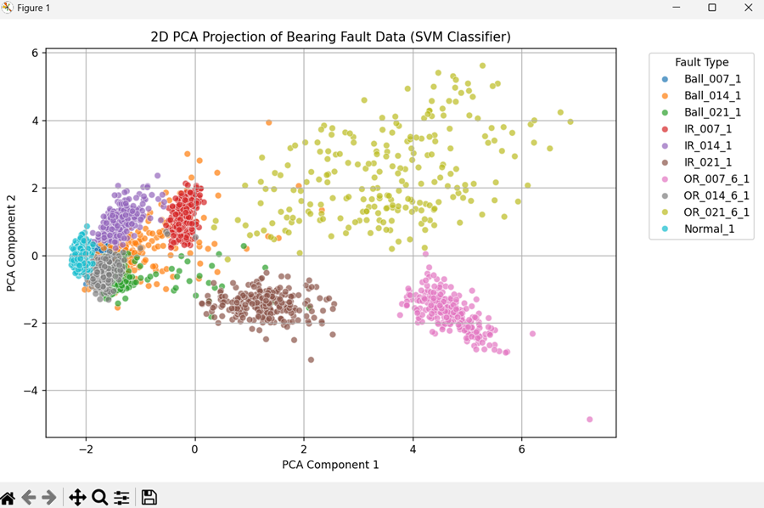
Figure 2: PCA projection using SVM classifier
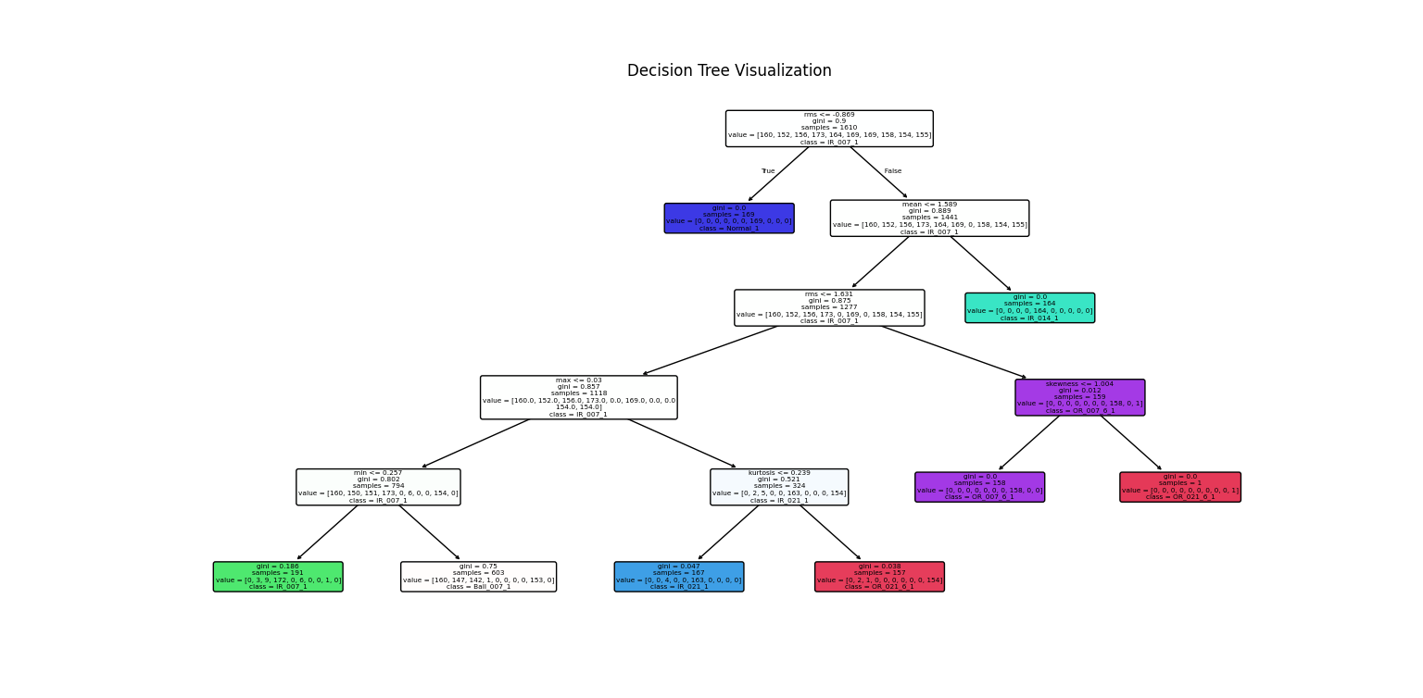

Figure 3: Decision Tree Classifier

5. Conclusion
This project successfully demonstrates the effectiveness of machine learning and deep learning techniques in the classification of bearing faults using vibration signal data. By extracting meaningful statistical features from the CWRU and Paderborn datasets and evaluating multiple supervised learning models, we identified that the Support Vector Machine (SVM) achieved the highest classification accuracy of 93.18%, making it the most reliable model for this task. The 1D Convolutional Neural Network (1D-CNN) also showed promising results, accurately classifying faults directly from raw time-series segments without manual feature engineering. While K-Nearest Neighbors (KNN) delivered competitive performance with simpler implementation, the Decision Tree model showed limitations in handling complex patterns. Overall, the project highlights that combining classical machine learning methods with deep learning approaches can lead to accurate, scalable, and robust fault detection systems suitable for real-world predictive maintenance in rotating machinery.

References
[1] J. Smith and L. Zhang, “Bearing fault diagnosis using time-domain statistical features and machine learning,” Springer Journal of Mechanical Systems, vol. 45, no. 3, pp. 215–230, 2020.
[2] Case Western Reserve University Bearing Data Center, “Bearing data center,” [Online]. Available: https://engineering.case.edu/bearingdatacenter.
[3] Paderborn University Bearing Data Center, “Vibration datasets for condition monitoring,” [Online]. Available: https://mb.uni-paderborn.de/kat/forschung/datacenter.
[4] F. Pedregosa et al., “Scikit-learn: Machine learning in Python,” Journal of Machine Learning Research, vol. 12, pp. 2825–2830, 2011.
[5] F. Chollet, “Keras: Deep learning for humans,” [Online]. Available: https://keras.io, 2015.
[6] Y. Lei, F. Jia, J. Lin, S. Xing, and S. X. Ding, “Intelligent fault diagnosis and prognosis for rotating machinery: A review,” Mechanical Systems and Signal Processing, vol. 72–73, pp. 105–144, 2016.
[7] W. Zhang, G. Peng, C. Li, Y. Chen, and Z. Zhang, “A new deep learning model for fault diagnosis with anti-noise and domain adaptation,” Sensors, vol. 17, no. 2, p. 425, 2017.
[8] H. Shao, H. Jiang, H. Zhang, and M. Niu, “Rolling bearing fault diagnosis using optimized deep belief networks,” Measurement Science and Technology, vol. 28, no. 3, p. 035005, 2017.
[9] O. Janssens et al., “Time series anomaly detection for machine condition monitoring using deep learning,” arXiv preprint arXiv:1611.05236, 2016.
[10] M. Boudiaf et al., “Domain adaptation for bearing fault diagnosis using adversarial training,” Applied Sciences, vol. 10, no. 14, p. 4814, 2020.
[11] S. J. Pan and Q. Yang, “A survey on transfer learning,” IEEE Transactions on Knowledge and Data Engineering, vol. 22, no. 10, pp. 1345–1359, 2010.
[12] T. Ince et al., “Real-time motor fault detection by 1D convolutional neural networks,” IEEE Transactions on Industrial Electronics, vol. 63, no. 11, pp. 7067–7075, 2016.
[13] R. Zhao et al., “Deep learning and its applications to machine health monitoring,” Mechanical Systems and Signal Processing, vol. 115, pp. 213–237, 2019.
[14] T. Wang et al., “A novel convolutional neural network for fault classification,” IEEE Transactions on Instrumentation and Measurement, vol. 67, no. 7, pp. 1627–1637, 2018.
[15] J. Zhu et al., “Few-shot learning for intelligent fault diagnosis,” IEEE Transactions on Industrial Informatics, vol. 17, no. 3, pp. 1733–1744, 2021.

